

ITA0330-Mobile Computing

Name: T. Dharani Devi Reg no:192425036

Slot: D Course Name: Mobile Computing

Experiment 2: Mobile Station User Interface Prototype

Aim: To design a user interface prototype for a mobile station considering connectivity and convenience.

Procedure:
- Open Figma and create a new design file.
- Select a smartphone frame from the device templates.
- Design the home screen with a simple layout.
- Add signal strength, battery status, and network connectivity indicators.
- Add call, SMS, contacts, and mobile data icons.
- Apply suitable colors, fonts, and buttons.
- Use Prototype mode to connect the screens and test navigation.

Output:

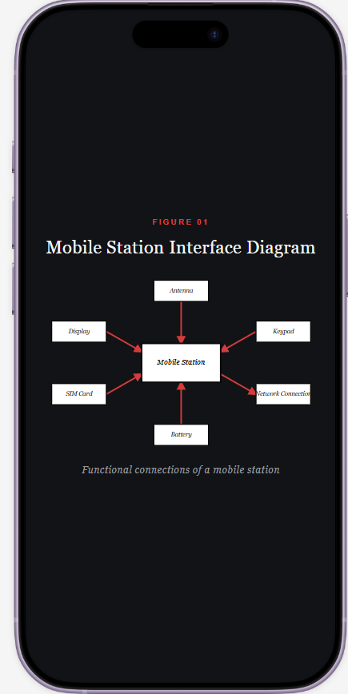

https://www.figma.com/make/GAxr2Oza1wWlYNxiMvumql/EXPERIMENT-2?t=AdyBiZOqFsRDmqlK-0

Result: Thus, a mobile station UI prototype with connectivity features and convenient navigation was designed successfully.

